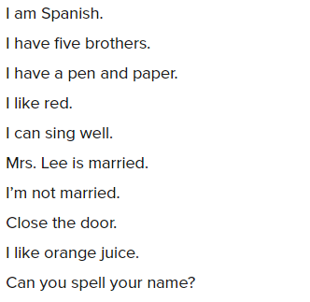

How are you?

This coffee is hot.

Antonio is a waiter.

These peppers are red.

My family has two cars.

They have three classes.

My brother and sister call me at work.

I talk to my mother and father.

She likes milk and sugar in her tea.

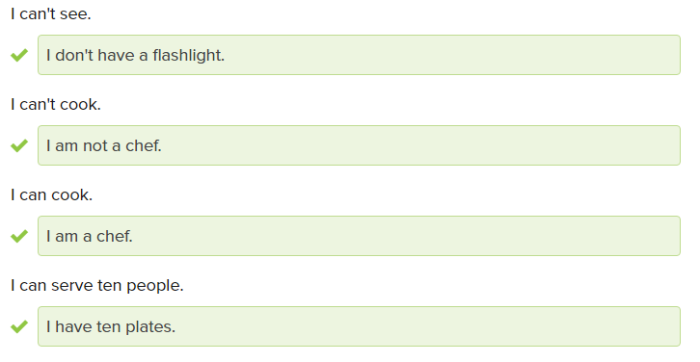

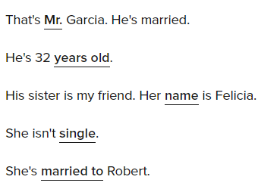

Close the door, Benny.

Please close your book.

Put down that apple and come here.

Don’t walk in the rain.

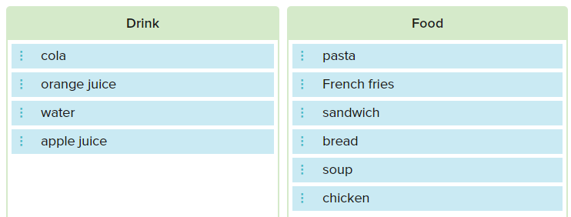

Do you have juice?

Can I order a sandwich?

Does he have a girlfriend?

Are they married?

Is he your friend?

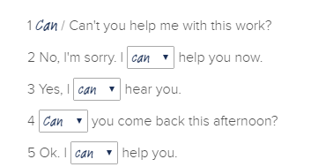

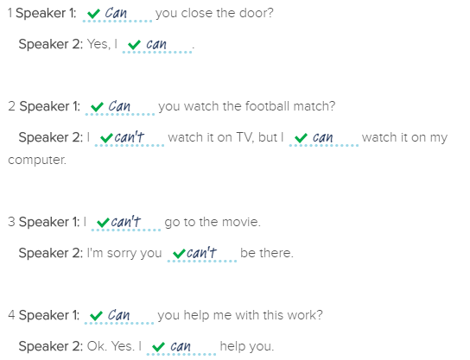

Sorry, I can / can't hear you.

He can’t walk.

Yes. I can fix this.

I can sing.

I can’t finish.

Can you please close the door?

No! I can't!

Can you help me?

Sure , I can help

I’m sorry. You can’t come in.

Can you fix it?

Yes. I can

I can’t find this restaurant. Can you help me?

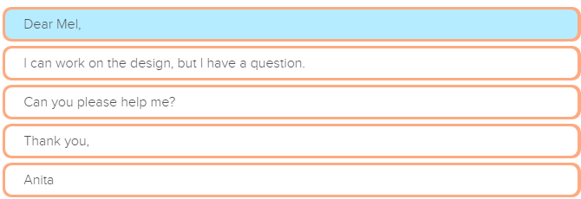

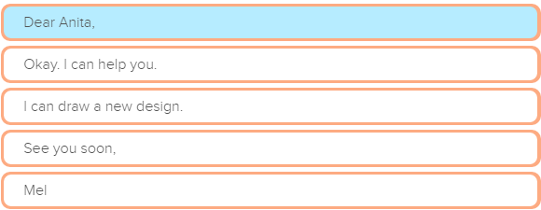

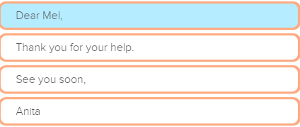

I like milk and sugar in my coffee.

Bring me the pen and paper, please.

Here is coffee and milk for you.

Thank you for your time and help with the design

Can you send your mother and father an email soon?

My brother and sister are here.

I need my laptop and phone for work

